**Science 8 Name___________________**

**Electromagnetic Radiation 6 - Using Mirrors to Form Images Date____________________**

1. __________________ (flat) mirrors
   1. E.g. __________________ from a lamp shines on a blueberry.
      1. This light reflects off all __________________ on the blueberry, in all __________________.
         1. Only the rays coming from __________________ point are shown.



* 1. All of the rays from the blueberry that strike the mirror __________________ according to the law of __________________.
     1. The rays that reach your __________________ appear to be coming from a point __________________ the mirror.
        1. The same process occurs for every __________________ on the blueberry.
  2. Your brain “knows” that __________________ travels in __________________ lines.
     1. Your brain interprets the pattern of light that reaches your __________________ as an __________________ of a blueberry __________________ the mirror.

1. Image size and distance



* 1. Rays are shown coming from three different __________________ on the bird.
  2. These rays __________________ off the mirror and back to the bird’s __________________.
     1. Notice that the points appear to be coming from __________________ the mirror.
     2. Each point appears to be coming from a point that is as far __________________ the mirror as the real point is in __________________ of the mirror.
     3. Also notice that the three points are exactly the same __________________ apart in the __________________ as they are on the __________________, the bird.
  3. A plane mirror produces an __________________ with the same __________________ as the object.
     1. If you are standing on your feet, a plane mirror produces an __________________ of you standing on your feet.
     2. The ray that diverges from the __________________ hand of the boy converges at what appears to be the __________________ hand of his image.
     3. __________________ and __________________ appear to be __________________ by a plane mirror.

 

1. A __________________ mirror is a mirror that curves __________________.
   1. __________________ mirrors reflect light rays to form __________________.
   2. __________________ light rays bounce off the curved surface of a __________________ mirror and then meet at a single point called the __________________ point.
      1. Light rays are __________________ (coming together) at the __________________ point.
   3. The __________________ formed by a concave mirror depends on how far the __________________ is from the __________________ point of the mirror
      1. If a __________________ object is reflected in a concave mirror, its image is __________________ and upside down.



* + 1. As the object approaches the __________________ point, its image remains __________________ but gets ever __________________.



* + 1. If the object is between the __________________ point and the __________________, then the image appears to be __________________ than the object and is __________________.



* 1. __________________ mirrors have many uses
     1. If a bright light is placed at the focal point, then all the light rays bounce off the mirror and are reflected __________________ to each other.
        1. This makes an intense, focussed __________________ of light.
        2. __________________, flashlights, lighthouses, and car __________________ use this kind of mirror.

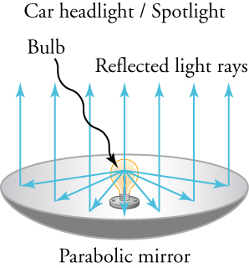 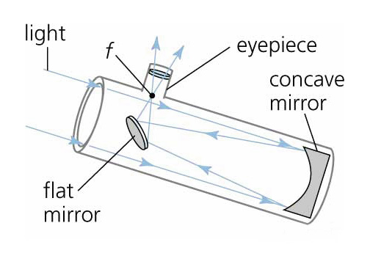

* + 1. The largest __________________ all use concave mirrors to collect __________________ because the __________________ concentrates the light so effectively.

1. A __________________ mirror is a mirror that curves __________________.
   1. Convex mirrors also reflect light rays to form an __________________, but in an __________________ way to concave mirrors.
      1. A convex mirror reflects __________________ light rays as if they came from a __________________ point __________________ the mirror
      2. Light rays that __________________ apart after reflecting are described as __________________.
      3. The image formed is always __________________ and __________________ than the actual object.

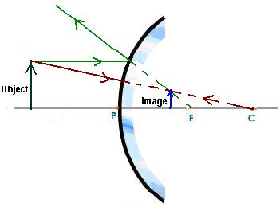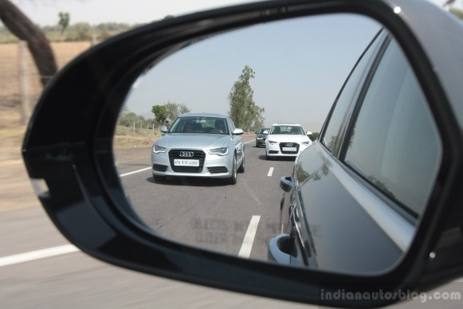

* + 1. More objects can be seen in a __________________ mirror than in a __________________ mirror of the same size.
  1. Security __________________, such as those in convenience stores, are large __________________ mirrors.
     1. Convex mirrors make it possible to monitor a __________________ region of the store from a single location.
     2. Convex mirrors can also __________________ the view of traffic that can be seen in rearview or side-view mirrors of automobiles.
        1. __________________ and __________________ seen in a convex mirror are not realistic
        2. Most __________________ side-view mirrors carry a printed warning that the objects viewed are __________________ than they appear to be