**Science 8 Name___________________**

**Electromagnetic Radiation 5 - Reflection and Refraction Date____________________**

1. To act as a ________________________, a surface needs to be ________________________compared to the ________________________of the light striking the surface
   1. Even though a surface may feel ________________________, microscopically the surface is ________________________and ________________________
   2. Light rays bounce off randomly at all ________________________, giving the surface the appearance of being ________________________
   3. Since the light is reflecting off the surface at many different ________________________, we can see the object from many different ________________________
      1. This is known as ________________________reflection

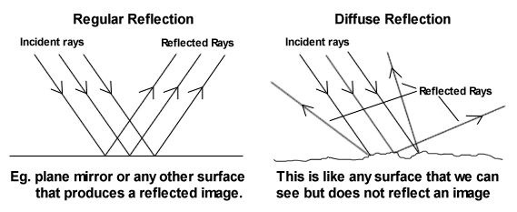

1. The Law of Reflection

__________________________

__________________________

__________________________

__________________________

________________________



__________________________

* 1. The incoming ray is called the ________________________ray.
  2. The ray that bounces off the mirror is called the ________________________ray.
  3. A dotted line has been drawn at ________________________angles to the mirror called the ________________________.
     1. The normal is an imaginary line that is ________________________to the boundary between two materials
     2. The angle formed by the ________________________beam and the ________________________is the angle of ________________________, labelled *i*.
     3. The angle formed by the ________________________beam and the ________________________is the angle of ________________________, labelled *r*.
  4. The angle is always measured from the ________________________line to the ________________________, not from the mirror to the ray.
  5. Observations for all types of surfaces have shown that the angle of ________________________is the ________________________as the angle of ________________________.
     1. Therefore, this observation is considered to be a ________________________.

1. Light can be bent, or ________________________, if it changes ________________________as it travels from one medium into another.
   1. When light rays move from air into ________________________, they slow down and change ________________________because the glass is ________________________than air.
      1. Once inside the ________________________, the light rays move in a ________________________line.
      2. But if the light rays leave the ________________________and move back into the ________________________, where they can travel ________________________, they will change direction again.
   2. The angle of ________________________ (*R*) is the angle of a ray of light emerging from the ________________________between two materials, such as from air into glass, measured between the ________________________ray and the ________________________.
      1. When a light ray passes into a medium in which it slows down, the light ray is refracted ________________________the normal.
      2. When a light ray passes into a medium in which it speeds up the light ray is refracted ________________________from the normal.



1. Refraction of Light in Water
   1. The light rays reflected from the fish are refracted away from the ________________________as they pass from ________________________to ________________________and enter your eyes.
   2. The brain assumes that all light rays have travelled in a ________________________line.
      1. The light rays that enter your eyes seem to have come from a fish that was ________________________in the water.



1. Refraction of Light in Air
   1. Refraction can also occur when light travels through air at different ________________________.
      1. ________________________air is ________________________dense than ________________________air.
   2. Light ________________________as it travels through different ________________________of air.
      1. The refraction of light through air can result in a ________________________, which is a misleading appearance or ________________________.
   3. E.g. the “________________________mirage” on a hot day
      1. The air closer to the ground is ________________________and less ________________________than air higher up.
      2. Light from the sky directed at the ground is ________________________upward as it enters the ________________________dense air.
      3. The “pools of water” are actually images of the ________________________refracted by ________________________air near the ground
      4. Our brain associates light ________________________off a surface as ________________________

