Science 8 Name___________________
Electromagnetic Radiation 3 – The Wave Properties of Light Date____________________

- Light is can be modelled as __________________________ since light exhibits certain __________________________ that are characteristic of any __________________________

  - Light __________________________ and __________________________ in the same manner that any wave would refract.

    - __________________________ involves a change in __________________________ of waves when they __________________________ off a barrier.

    - __________________________ of waves involves a change in the __________________________ of waves as they pass from one __________________________ to another.

  - There are three other behaviors that light can exhibit

    - Light __________________________

    - Light undergoes __________________________

    - Light exhibits the __________________________ effect

- __________________________ involves a change in __________________________ of waves as they pass through an __________________________ or around an __________________________ in their path.

  - Water waves have the ability to travel around __________________________, around __________________________ and through __________________________.

    - __________________________ waves do the same.

  - When __________________________ encounters an __________________________ in its path, the obstacle blocks the __________________________ and tends to cause the formation of a __________________________ in the region behind the obstacle.

    - Light does not exhibit a very noticeable ability to __________________________ around the obstacle and fill in the __________________________ behind it with light.

    - Light does __________________________ around obstacles.

      - If you observe a __________________________ carefully, you will notice that its edges are extremely __________________________.

- Wave __________________________ is the phenomenon that occurs when two waves meet while traveling along the same __________________________.
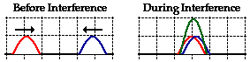
  - __________________________ interference is a type of interference that occurs at any location along the medium where the two interfering __________________________ have a displacement in the __________________________ direction.

    - The result is that the two pulses __________________________ onto each other when they are completely overlapped

  - __________________________ interference is a type of interference that occurs at any location along the medium where the two interfering __________________________ have a displacement in the __________________________ direction

    - The result is that the two pulses completely __________________________ each other when they are completely overlapped.

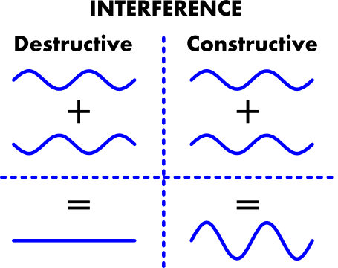
  - The __________________________ of waves led to a very important experiment

    - If the waves from two __________________________ of waves meet they will undergo __________________________
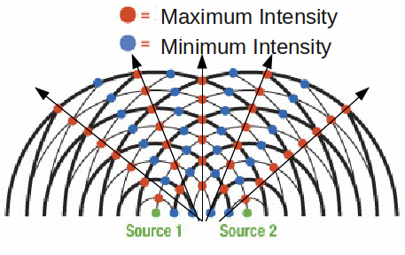
- In 1801, Thomas Young devised a way to show that __________________________ waves could show a similar pattern of __________________________

      - Light was passed through two small __________________________ to create two __________________________ of light

      - The two sources of __________________________ created a pattern consistent with the __________________________ pattern
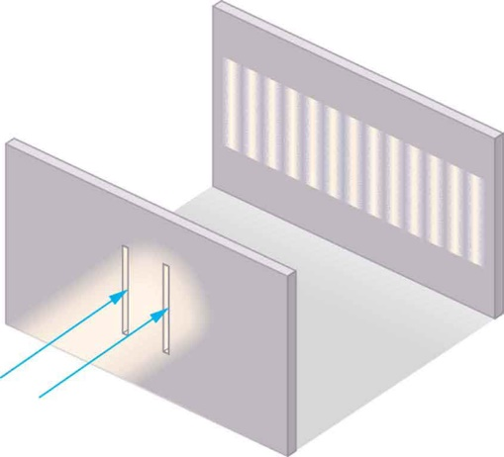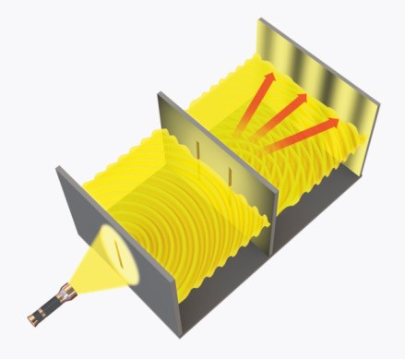
- The __________________________ effect is observed whenever the __________________________ of waves is __________________________ with respect to an observer.

  - It is the effect produced by a moving source of waves in which there is an apparent

    - __________________________ shift in frequency for observers towards whom the source is __________________________

    - __________________________ shift in frequency for observers from whom the source is moving __________________________.
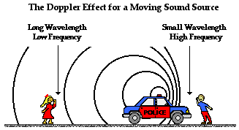
  - The belief that the universe is __________________________ is based in part upon observations of electromagnetic waves emitted by __________________________ in distant galaxies

    - The __________________________ from galaxies tends to shift to the __________________________ end of the spectrum

    - The __________________________ waves from galaxies are being __________________________ as the galaxies move __________________________

