**Science 8**

**Electromagnetic Radiation 3 – Light and the Electromagnetic Spectrum**

1. No matter where you are, you are surrounded by ________________________ waves.
   1. Even though you cannot ________________________ them, some of these waves are travelling right through your ________________________.
      1. E.g. ________________________ waves, microwaves, ________________________ waves

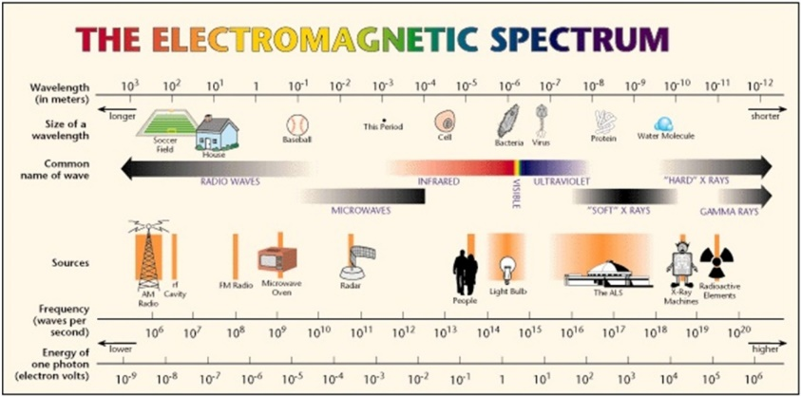

1. The ________________________ is the most important source of ________________________ on Earth.
   1. Light spreads out, or ________________________, from the Sun and other stars in all ________________________, like the spokes of a bicycle wheel.
      1. Energy, such as ________________________, that travels by ________________________ is often called ________________________ energy.
   2. In addition to the ________________________ energy that we call ________________________, the Sun also radiates ________________________ energy.
      1. The ________________________ we see is just a tiny band of a much broader ________________________ of energy



1. Light is a different kind of ________________________ from those that travel through ________________________.
   1. In a water wave, water particles ________________________ upand down as the wave passes through the water.
   2. In a light wave, ________________________ and ________________________ fields vibrate.
      1. As a result, light is classified as ________________________ radiation.
   3. Visible light energy and all the invisible forms of ________________________ energy exist on the ________________________ spectrum
   4. Electromagnetic radiation is the transmission of ________________________ in the form of ________________________ that extend from the longest radio waves to the shortest gamma rays.
      1. Various devices have been developed to ________________________ other frequencies.
         1. E.g. the ________________________ of your radio detects ________________________ waves.
2. ________________________ waves are a type of electromagnetic radiation that have the ________________________ wavelength and ________________________ energy and frequency compared to all other types.
   1. Different ________________________ of radio waves have different uses
      1. E.g. ________________________ and ________________________ broadcasting
      2. E.g. ________________________ and ________________________ are types of radio waves



* 1. In magnetic resonance imaging (MRI), a patient lies in a large cylinder that is equipped with a powerful ________________________, a ________________________ wave emitter, and a ________________________ wave detector.
     1. Particles in the ________________________ and soft ________________________ behave like tiny ________________________ and can be lined up.
     2. When the MRI machine causes the orientation of the ________________________ to flip, they produce ________________________ waves.
        1. The released ________________________ is detected by the radio receiver and used to create a map of the different ________________________



* 1. Microwaves have the ________________________ wavelength and the ________________________ frequency of all the radio waves.
     1. Microwave ovens use a ________________________ wavelength (or frequency) of microwave that is strongly absorbed by ________________________ particles.
        1. When the ________________________ particles in the food absorb microwaves, they begin to ________________________ quickly and become ________________________.
        2. Only foods that contain ________________________ particles can be heated using microwaves.
     2. ________________________ frequencies are also used in telecommunications
        1. Microwaves can be transmitted to telecommunications ________________________ that orbit Earth.
        2. Some radio telescopes are directed toward distant ________________________ and ________________________ to learn more about the composition, motion, and structure of these distant objects.

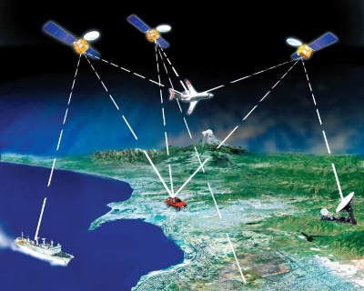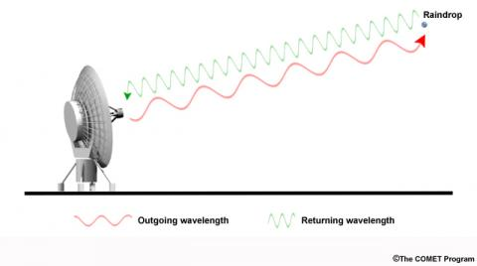

* 1. Shorter wavelength microwaves are used in remote sensing, such as ________________________.
     1. Microwaves are ________________________ out through the air.
        1. The waves that ________________________ from an object can show the ________________________ and ________________________ of the object.
     2. Radar is used for tracking the ________________________ of automobiles, aircraft, watercraft, and spacecraft.
     3. Raindrops, snow crystals, and other objects in the air ________________________ radio waves.
        1. ________________________ radar, electronically convert the reflected radio waves into pictures that show the ________________________ and intensity of precipitation and the ________________________ of the wind.

1. ________________________ waves are a type of electromagnetic radiation that, relative to light, has a ________________________ wavelength and ________________________ energy and frequency.
   1. A ________________________ control emits infrared waves to control a ________________________ set.
   2. Infrared radiation is also referred to as ________________________ radiation.
      1. Every object emits some ________________________ waves because all objects contain some ________________________ energy.
         1. Warmer objects emit ________________________ infrared waves than ________________________ objects
2. ________________________ waves are a type of electromagnetic radiation that, relative to light, has a ________________________ wavelength and ________________________ energy and frequency.
   1. This radiation is very ________________________.
   2. Ultraviolet radiation striking your ________________________ enables your body to make vitamin D, which you need for healthy ________________________ and ________________________
      1. Overexposure to ultraviolet radiation can result in ________________________ and skin ________________________, and damage to the ________________________ of the eye.
   3. Fluorescent materials absorb ultraviolet waves and ________________________ the energy as visible ________________________.
      1. Police detectives sometimes use fluorescent powder to study ________________________ when solving crimes.
      2. Ultraviolet waves are also able to kill ________________________ in food, water, and medical supplies.
3. X rays are a type of electromagnetic radiation that have a much ________________________ wavelength and ________________________ energy and frequency than ultraviolet waves.
   1. Doctors and dentists use low doses of X rays to form images of internal ________________________, ________________________, and ________________________.
   2. Airport security personnel use X-ray screening devices to examine the ________________________ of ________________________.
   3. X rays can also be used to inspect for ________________________ inside high performance jet engines without taking the engine apart, and to photograph the inside of ________________________
4. ________________________ rays are the ________________________ energy and frequency and shortest wavelength portion of the electromagnetic spectrum.
   1. Gamma rays result from ________________________ reactions and are produced by the ________________________ regions of the universe.
   2. Focussed bursts of gamma rays are used in ________________________ therapy to kill ________________________ cells.